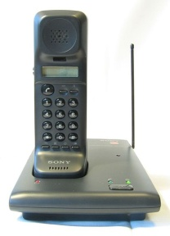 USEFUL PHONE NUMBERS

Doctors – Martock
01935 822541
Martock Pharmacy
01935 822554.
Doctors – Petherton
01460 240707
South Petherton Pharmacy
01460 242269
Doctors – Langport
01458 250464
Pharmacy – Martock
01935 822554
Pharmacy – Langport
01458 250552
Neighbourhood Watch – Olwen Herridge
01458 241244

Pastoral Matters – By App to The Angel, Bow Street, Langport
Via Church Office (see Below)

Pastoral Matters – Church Office – Clive Sills
01458 251881

Slinky Community (on demand) Bus Service
01935 477339

